
COUNCIL OF EUROPEAN MUNICIPALITIES AND REGIONS
european section of united cities and local governments

Conference

a European Town For Equality

★ Brussels, 7th & 8th February 2005 

- SPEECHES -

in the European Parliament:
Rue Wiertz 13
Paul-Henri Spaak building, room P1A002
1047 Brussels (B)

Conference organised by the CEMR and the
“Sister Cities Going Gender” network,
with support from the european commission,
in the framework of the 5th community action programme for equality between women and men

2.2.2005

Conseil des Communes et Régions d'Europe ● Council of European Municipalities and Regions
15 Rue de Richelieu F-75001 Paris 22 Rue d’Arlon B-1050 Bruxelles
tel : + 33 1 44 50 59 59 cemr@ccre.org - www.ccre.org Tel : + 32 2 511 74 77

MONDAY FEBRUARY 7TH

14 h 30 Opening session

- Vicenta Bosch Palanca, President of the CEMR Committee of women elected representatives of local and regional authorities



- Luisella Pavan-Woolfe, Director for Horizontal and International issues, DG Employment, Social Affairs and Equal Opportunities, European Commission

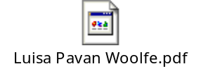

- Anna Zaborska, President of the Women’s Rights and Gender Equality Commission of the European Parliament



15 h 00 Introduction to the conference: Towards an equal town

- Françoise Gaspard, CEMR expert and author of the CEMR methodology

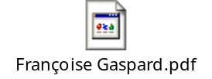

- Jeremy Smith, CEMR Secretary General

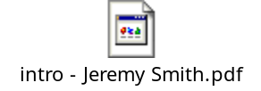

16 h 00 Round Table : for an increased participation of women in the decision making process

- Diane Bunyan, Expert within the Council of Europe



- Ann-Kristin Copson, Gender Expert, Norwegian Association of Local and Regional Authorities



- Paz Fernández Felgueroso, Mayor of Gijón

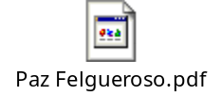

- Catharina Tarras-Wahlberg, Deputy Mayor of Stockholm

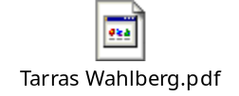

- Beate Weber, Mayor of Heidelberg



TUESDAY FEBRUARY 8TH

9 h 30 A strategic approach for a town in which women’s lives are made easier

- Michaela kauer, Representing the City of Vienna

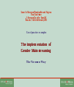

- Rossella Bonavita, in charge of the “Cittadinanza e delle Donne” for the City of Venice

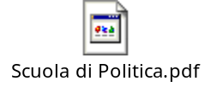

- Audrey Young, Head of Diversity, Performance, Greater London Authority (GLA)



- Marianne van den Anker, Deputy Mayor of Rotterdam in charge of emancipation, security and health

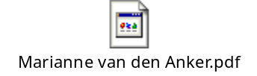

- Luc Gwiazdzinski, Director of the Maison du Temps et de la Mobilité (House of time and mobility), Belfort Municipality

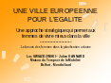

- Elizabeth Johnston, Deputy Executive Director of the European Forum for Urban Safety

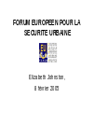

11 h 15 Equality between women and men in the town as an employer

- Susanna Rorato, Head of Equal Opportunities within the City of Turin, and Davide Diamantini, Professor at the University of Bicocca-Milano

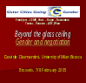

- Jocelyne Bougeard, Deputy Mayor of Rennes in charge of women’s issues & equality and the city’s timing policy

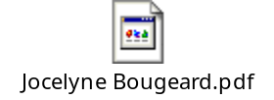

- Ewa Mroz, Director of the House for Polish-German Cooperation

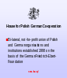

12 h 00 A town for diversity

- Natalia Izzi, member of the City of Rome’s Equal Opportunities Committee

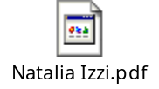

14 h 00 Equality in the town as a service provider

- Jan Youngs, representative of the Bristol Women’s Forum



15 h 00 Closing Ceremony

- Conference conclusions by Jeremy Smith, CEMR Secretary General



- Edite Estrela, Vice-Chairwoman of the EP Committee on Women's Rights and Gender Equality



- Emilia Saiz, United Cities and Local Governments



- Vicenta Bosch Palanca, President of the CEMR Committee of women elected representatives of local and regional authorities
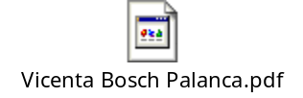

    - Jeremy Smith: Words of thanks

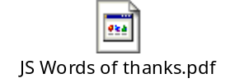

16 h 00 End of activities

